Level 2 Questions
1. What are the two parts of the main rule of race walking?
2. What do these paddles mean?
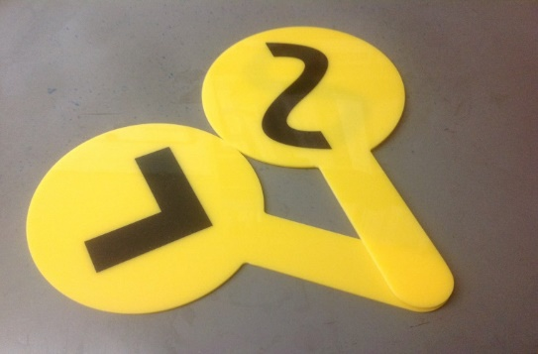

3. When would these paddles be shown to the competitors?
4. Can a judge show the same paddle more than once to the same competitor?
5. Why is a red card completed and what happens to it once that has been done?
6. What is a red paddle used for and who would use it?
7. Where is the best position from which to judge at a track event?
8. Where is the best position from which to judge at a road race?
9. Where are competitors most likely to break the rules of race walking? Give at least two examples

