These are the Starter/Starters’ Assistant Questions which should be completed for accreditation to Level 2.

Useful resources: UKA Rule Book 2022 – 2024; Level 1 Candidate Resources, conversations with your peers; and…….for later World Athletics Starters Guidelines 2018

Instructions

Level 2 Starters – Complete Sections 1 and 3
Level 2 Starters Assistant – Complete Sections 1 and 2

The numbers in brackets after each question indicate the maximum marks available for that question.

Section 1 – Total of 55 Marks, Section 2 – Total of 26 Marks,
Section 3 – Total of 75 Marks

Section 1 – All Candidates

1-1 There are certain rules governing the construction and setting of starting blocks.

- Why is it permissible for the rear of the block to extend beyond the outer lane line and not the inner lane line? (2)

- Describe how a set of blocks should be constructed. (2)

1-2 This question refers to the clothing and shoes which athletes wear.

- List the two minimum items of clothing that must be worn by an athlete competing in a track race? (2)

- What do the rules require of these two items? (2)

- What does the Rule require of vests for all competitors in a team or relay race? Are there any exceptions under UKA rules? If so, who makes the decision? (4)

- In the Rule on footwear, what is the maximum length of spike allowed on a synthetic surface? (Note: in practice some stadia will specify a shorter maximum length - your answer should be the specified length in the Rule) (1)

- An athlete comes to the start line clearly wearing spikes the sole of which looks as if it is 15mm thick. You notice that the sole only contains 9 out of the permissible number of needle spikes. Describe your course of action, if any. (3)

1-3 This question refers to competitors’ numbers.

- How many competitors' numbers should be worn by each athlete in a track race? Do not include any numbers which refer to lane order. (1)
- Where and how should they be worn? (2)

- When photo-finish equipment is being used, where should the photo-finish number be fixed, assuming the camera is in the normal position, on the outside of the track, level with the finishing line? (1)
- An athlete comes out onto the track wearing numbers where it is obvious that he has cut the sponsor’s advertising off to make the number more comfortable to wear. When advised by you, as a starter’s assistant, he refuses to do anything to rectify the situation. Describe your course of action, with reasons, giving any other relevant senior officials who could/should be involved. (5)

1-4 This question is about equipment you need at the start.

Name 5 items which you would expect to find in a starters assistant’s bag. Which 2 would you consider essential. Give your reason for your choice of essential items. (9)

1-5 Which cards would be shown show under UKA rules?

- Under15 boy’s 100m first false start by any athlete (1)

- Under 20 women 100m first false start by any athlete (1)

- Senior men 110 mH Decathlon first false start by any athlete (1)

- Senior Women 200m Heptathlon second false start by any athlete (1)

1-6 The following questions refer to possible scenarios which could arise at the start.

- An athlete withdraws from the 200m final without giving the track referee a valid reason. The same athlete appears at the start for the 400m race. What action should you take and why? (4)

- You are the starter’s assistant on a 200m start. The athletes are on their marks and you have stepped back. Before the ‘set’ command you notice that the knee of an athlete has lost contact with the ground. What action should you take? (4)

- You are the starter’s assistant on a 400m start and “have the line”, as such, you are opposite lane 8. When the ‘set’ command is issued the athlete in lane 8 fails to respond. What action should you take and which other official(s) should be involved? (4)

- You are the starter’s assistant on a 100m start and are checking the athletes against the lane draw. Photo finish is being used at the meeting and the Chief Starter’s assistant has a radio. The athlete in lane 3 has a different bib number to the one on the lane draw sheet. What action would you take? What would be the problem if you did not take action? (5)

- An athlete comes to register early for the start of a 100m heat but has, at the same time, a long jump competition on the far side of the track. The athlete is in heat 6 and the long jump competition is in the warm up phase. How would you manage the situation to allow the athlete to participate in both competitions? (5)

Section 2 – Starter’s Assistants Only

2-1 This question concerns the set up at the start of a County level 3000m with 24 senior men. (10)

Use the diagram to indicate where you would deploy the following athletes and officials.
- Starter’s assistant(s)
- Mark with an X where you would call up the athletes
- Mark with a blue line where you would assemble the athletes

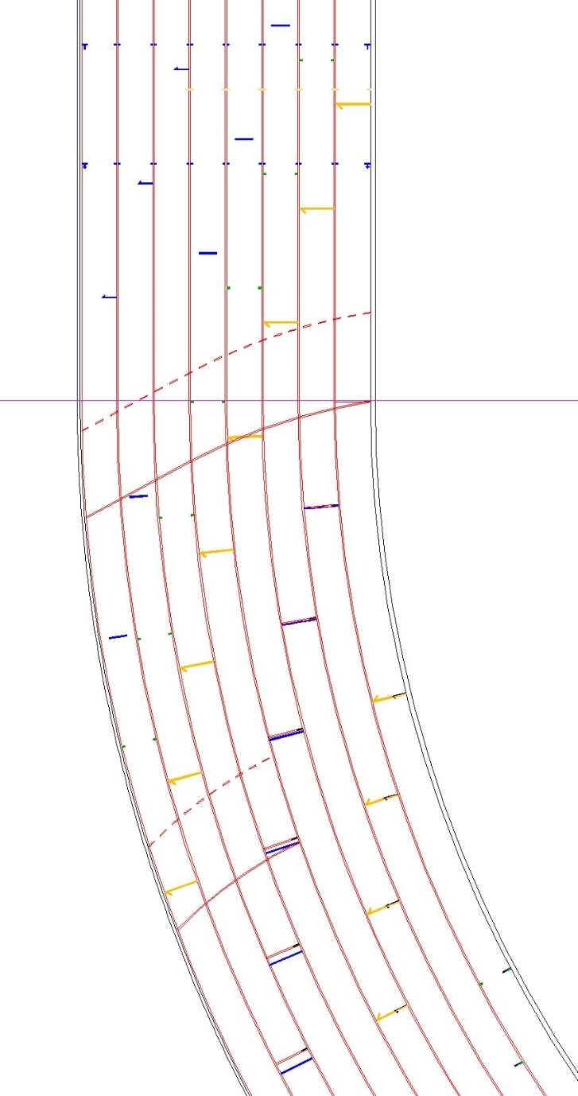

2-2 This question concerns the set up at the start of a County level series of 100m junior girl’s heats. (10)

Use the diagram to indicate where you would deploy the following athletes and officials.

- Starter’s assistant(s)
- Mark with an X where you would call up the athletes
- Mark with a blue line or cross where you would assemble the athletes

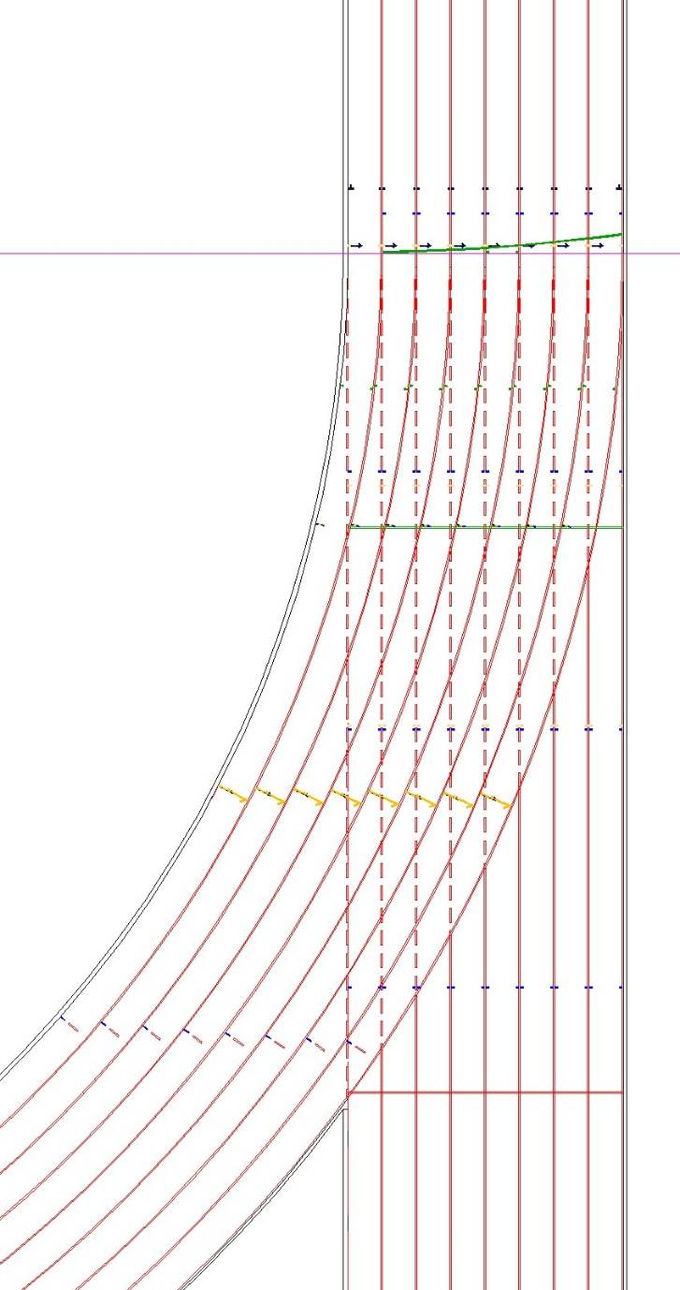
Please note the straight green line indicated by the blue arrow is the start line.

2-3 Moving forward think about this question

At your 2 day County Championship you have been appointed Chief Starters’ Assistant. You have the luxury of 2 starters’ assistants plus yourself as chief. Give a brief account as to how you would deploy your staff.(6)

Section 3 – Only Starters Should Attempt This Section

3-1 This question is about equipment you need at the start.

Name 5 items which you would expect to find in a starter’s bag. Excluding guns and ammunition. Which 2 of the remaining items would you consider essential giving reasons for your choice. (9)

3-2 This question is about the start procedure.

- Why should the recall gun not be cocked? (2)
- Should all holding times be the same? Explain your answer. (2)
- When should the starting gun be reloaded? (1)

3-3 The following questions refer to possible scenarios which could arise at the start.

- The athletes in a 200m are on their marks and the athlete in lane 5 raises a hand. What action could the starter take? Explain your answer. (4)

- The track referee thinks that the start was unfair and comes to you to complain. What would your course of action be and why? (2)

- The athletes in a 100m race are on their marks. What reasons might the starter have for asking the athletes to ‘Stand Up’? (5)

- You are the starter in a 400m senior race. You call the athletes to their marks. The athletes settle but then the athlete in lane 2 rises into the set position before the ‘Set’ command is given. What possible actions might you take to deal with this situation? What sanctions, if any, are available? What UKA rule would be involved in such sanction? (6)

3-4 This question concerns the set up at the start of a County level 3000m with 24 senior men. (13)

Use the diagram to indicate where you would deploy the following athletes and officials.
- Starters)
- Starter’s assistant(s)
- Mark with an X where you would call up the athletes
- Mark with a blue line where you would assemble the athletes

3-5 There is a shot put competition taking place in and around the blue circle.

Describe, in detail, your course of action, include in your answer who you might liaise with and the reasons you would do this. (6)

3-6 This question concerns the set up at the start of a County level series of 100m junior girl’s heats. (13)

Use the diagram to indicate where you would deploy the following athletes and officials.
- Starter(s)
- Starter’s assistant(s)
- Mark with an X where you would call up the athletes
- Mark with a blue line or cross where you would assemble the athletes

Please note the straight green line indicated by the blue arrow is the start line.
3-7 Moving forward think about these questions.

- You have been appointed Start Coordinator at your 2 day County Championships. What paperwork would you need to prepare in advance of the meeting? Who would you need to contact in advance and what would you need to tell/ask them? (10)

- You are appointed Chief Starters’ Assistant at a 2 day County Championship. You have the luxury of 2 starters’ assistants plus yourself as chief. Give a brief account as to how you would deploy your staff.(6)

